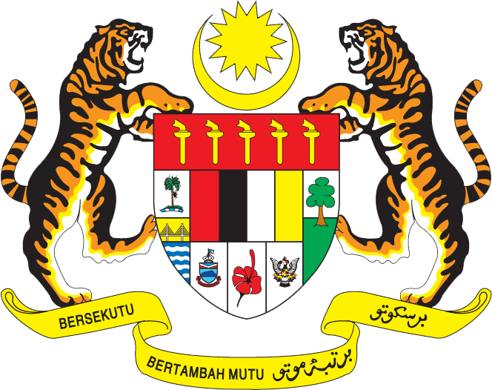

Statement by Mr. Zahid Rastam, Deputy Permanent Representative
Permanent Representative of Malaysia to the United Nations Office and Other International Organizations in Geneva
Review of the State of Timor-Leste
26th Session of the UPR Working Group of the Human Rights Council
31 October - 9 November 2016

Thank you Mr. President,

My delegation congratulates the delegation of Timor-Leste for the successful presentation of the report.

- Malaysia acknowledges the developments in the promotion and protection of human rights in Timor-Leste. Among others, Malaysia notes that concrete efforts have been undertaken by the Government of Timor-Leste to strengthen its judicial system, overcome discrimination and violence against women, and reduce unemployment in the country. My delegation is encouraged to learn about the positive results from the implementation of mobile courts, which have improved access to justice for people living in remote areas and expedite the resolve of pending cases in those areas. Malaysia also commends the openness demonstrated by Timor-Leste in reaching out and receiving technical assistance bilaterally, regionally and internationally towards the fulfilment of human rights in the country.

- In the spirit of constructive engagement, my delegation would like to propose the following three recommendations for the consideration of Timor-Leste:

  - One: intensify efforts in recognizing and highlighting the contribution of women to national economic, social and political development, uplifting women from poverty, and providing victims with adequate protection and recourse to justice in cases of violence against women;

  - Two: continue to implement and increase the effectiveness of national policies on persons with disabilities, including on access to education, access to public services, work opportunities, as well as adequate training and awareness programs to mainstream the rights of persons with disabilities to the public; and

  - Three: combat all forms of violence and exploitation against children including incest, human trafficking and human organ trafficking, ensure their access to justice, and provide rehabilitation of victims into the society.
.
I thank you, Mr. President.

GENEVA
3 November 2016

